

LETTER OF ACCEPTANCE
FOR SCIENTIFIC ARTICLES PUBLICATION
No. 02/JSE/LoA/9-IX/2026

Chief of Editor Journal Spektrum Ekonomi (JSE) has decided that the name article below has been accepted on JSE will be published in Vol 9 No 9 2026.

Author | : Putri Fitriani¹, Irna Maya Sari²
Email | : fitrianiputri976@gmail.com¹ ,irnasari.maya@gmail.com²
Title | : PENGARUH CASH HOLDING, LEVERAGE, DAN HARGA SAHAM  TERHADAP MANAJEMEN LABA PADA PERUSAHAAN SEKTOR  HEALTHCARE YANG TERDAFTAR DI BURSA EFEK INDONESIA  TAHUN 2020-2024
Affiliation | : Universitas Pamulang

Thank you for submitting your article to our journal. We wish you all possible success in the future.

Warm regards,


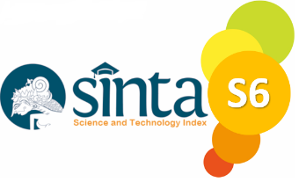





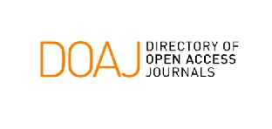
Journal Spektrum Ekonomi
Chief Editor

